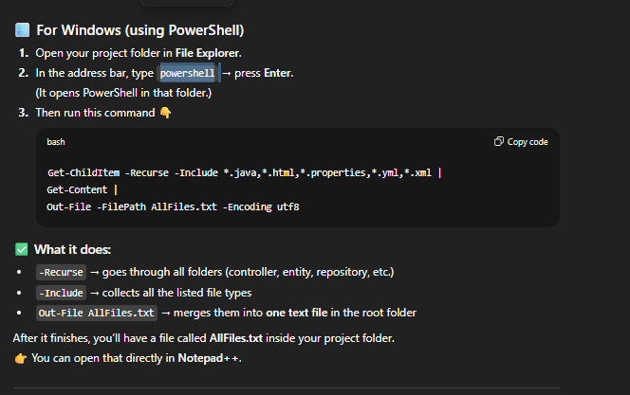
Get-ChildItem -Recurse -Include *.java,*.html,*.properties,*.yml,*.xml |
Get-Content |
Out-File -FilePath AllFiles.txt -Encoding utf8

